**Fully Automated Solar Grass Cutter**

**Abstract:**

The fully automated solar grass cutter is a fully automated grass cutting robotic vehicle powered by solar energy that also avoids obstacles and is capable of fully automated grass cutting without the need of any human interaction. The system uses 6V batteries to power the vehicle movement motors as well as the grass cutter motor. We also use a solar panel to charge the battery so that there is no need of charging it externally. The grass cutter and vehicle motors are interfaced to an 8051 family microcontroller that controls the working of all the motors. It is also interfaced to an ultrasonic sensor for object detection. The microcontroller moves the vehicle motors in forward direction in case no obstacle is detected. On obstacle detection the ultrasonic sensor monitors it and the microcontroller thus stops the grass cuter motor to avoid any damage to the object/human/animal whatever it is. Microcontroller then turns the robotic as long as it gets clear of the object and then moves the grass cutter in forward direction again.

**Introduction**

Nowadays pollution is a major issue for whole world. Pollution is manmade and can be seen in own homes. In case Gas powered lawn mowers due to the emission of gases it is responsible for pollution. Also the cost of fuel is increasing hence it is not efficient. So the Solar powered grass cutters are introduced. Solar powered lawn mower can be described as the application of solar energy to power an electric motor which in turn rotates a blade which does the mowing of a lawn. But the cost of those grass cutters is high. But our automatic grass cutter is consisting of rechargeable battery. This design is alternative for environmentally hazardous gas powered grass cutter. Hydrogen powered lawn mower has been operated without major interruption during the past fourteen years. The commercial model was originally running on gasoline and was adapted to hydrogen by making small adjustments to the carburettor and by installing a hydrogen reservoir containing solid-state metal hydrides. During the evaluation period the only maintenance work was changing the lubricating oil of the engine once a year, and reactivating the metal hydride powder by external heating after an accidental inlet of air into the reservoir. And also it will be the alternative for solar powered automatic grass cutter because its cost is more. So automatic grass cutter using rechargeable battery is economically helpful for user. By using this automatic grass cutter user can the cut the grass of the required area by giving input by using keypad. Also the height of grass can be specified by adjusting the height of blades. The main objective of this grass cutter is that the grass in the lawn must be mown with less effort. Also to cut the grass of particular area as per user requirement. The sensors are the eyes of this grass cutter. The other objective is that the automatic grass cutter has to differentiate between grass and concrete while monitoring its surroundings continuously. We wanted an ultrasonic sensor to detect if the grass cutter was heading into an object. Safety is the main concern while designing the grass cutter. As it has blades we wanted our grass cutter not to be in operating mode if it was being held in the air by the user. Knowing that the user would be randomly holding the grass cutter we needed a sensor to detect orientation. The accelerometer was hence used in grass cutter so that it will not operate when user hold it. An automatic grass cutter will relieve the consumer from mowing their own lawns and will reduce both environmental and noise pollution.

An automatic lawn cutter that will help the user to cut the grass in their lawn with less efforts. The different sensors are used it will detect and avoid objects and humans while mowing. The main objective of this automatic lawn cutter is that the user can specify the area that is to be mown and also the height of grass as per there requirement by using the keypad. This design contains a microcontroller like ATmega, multiple sensors, Solar Panel, Motors, Chassis etc. This project provides a design method of an automated lawn mower, whose task is to cut grass whilst following a specified pattern with no need of user interaction. This task is expected to be made possible by using sensors to provide a microcontroller with measurement of distance.

**Solar Energy**

Solar energy is very large, inexhaustible source of energy. The power from the sun interrupted by earth is approximately 1.8/10MW, which are many thousands of times larger than the present consumption rate on the earth of all energy sources.

The quantum of energy India’s land area receive from sun is equivalent to 15,000 time sits consumption requirement (500 billion kWh) as projected for 2004. In addition to its size, solar energy has two other factors in its favor. Firstly, unlike fossil fuels and nuclear power, it is an environmentally clean source of energy. Secondly, it is free and available in adequate quantities in almost all parts of the world people live. But there are some problems associated with its. The real challenge in utilizing solar energy is of and economic concern.

One has to strive for the development of cheaper methods of collection and storage so that large initial investments required at preset in most applications are reduced, solar energy in India:

A large amount of solar radiation fall on India and for most of the country very few days are without sunshine. India lies within the latitude of 7 N to and 37 N with annual average intensity of solar radiation as500 to 600 cal/cm/day with more such insulations available in arid and semi arid regions. Average solar radiation falling on India in arid and semiarid regions is 7.5 K w h/m/day. Solar energy 5× 10 K w h/year potential to meet basic energy needs of teeming millions who live in rural India.

Solar energy is an important, clean, cheap and abundantly available renewable energy. The sun radiates heat and light. The heat, light received from the sun supports the environment on the earth through the following well known natural effects.

• Temperature balance on the earth

• Photo-synthesis by biological plantsm production of oxygen and organic materials, production of organic chemicals and biomass.

• Wind due to unequal heating of water, land surfaces.

•Heating of ocean water: ocean thermal energy (OTEC)

• Waves in ocean: ocean wave energy

• Tides in ocean: ocean tidal energy (due to gravitational forces)

The sun produces enormous amount of energy of heat and light through sustained nuclear fusion reactions. The solar energy received on the earth in the form of radiation is used for heating and producing an electrical energy.

Among the non-conventional sources of energy solar energy is the most promising. Hence our project is based on the solar energy conversion to mechanical energy to run a normal grass cutter.

**Objectives-**

Existing automated lawn mowers each have a distinct working principle, for instance the Robomow from Friendly Robotics (2011) requires the user to perform a onetime set up where the garden perimeter is set. The perimeter is set using a battery powered wire that is laid around the outer edges of the garden and any area where the robot is not to cover. Special sensors inside Robomow enable the wires to be recognized and the robot is therefore kept within the designated area. The robot travels on the garden in a systematic criss-cross pattern, several times from side to side to ensure that the entire area is covered and that the grass is cut from different angles (Friendly Robotics, 2011). Other technologies work around a similar principal as the Robomow, in the sense that it requires a perimeter wire to limit its cutting area. A difference between them may be added features and the cutting pattern, for instance the Lawn Bott and the Husqvarna both have a random operating principle (LawnBott 2011, p. 7 and 8), in the sense that they do not follow any specific cutting pattern.

**Existing Technology-**

The operation method of the Robomow although effective, is to a certain degree inefficient and contribute to a quite costly end product. The main advantages of their design include, virtually any size or shape of garden can be specified, it is flexible and it can work without requiring the user intervention at any stage, can operate at surface areas with slopes, these points can also constitute a disadvantage. The system design has the following disadvantageous aspects:

• The size and shape of the garden- as wires have to be placed in the garden area to be covered by the robot; the cost of the entire system may be considerably higher depending on the size. In the case of many plants being in the middle of the garden area, the setup can become cumbersome.

• Damage or faults – the wires are set on the grass and although the company mentions the fact that they would typically be covered by grass and become unnoticeable in a matter of 2 to 3 weeks the wires are prone to damage. The damage can be from any origin for example, pets can dig up and damage the wire, over time due to weather it can wear off, amongst others.

• A fault on the wire can provide incorrect information to the device and as consequence the device will not work as expected.Cutting pattern inefficiency – the criss-cross pattern for Robomow and the random one used by LawnBott and Husqvarna are all not very efficient due to the fact that it is required that the robot

**LITERATURE REVIEW**

For designing of Automatic Grass cutter we referred various literature, papers etc. The review of previous method used given below: In this lawn mower uses an solar based energy source, which is easier to use, more advantageous comparing to other energy source especially for gas based source of power .But our grass cutter is not based on solar because of its cost and may create some complexity during working. So we avoided solar powered lawn mower. In this hydrogen based lawn mower, the advantage of powering a lawn mower by hydrogen rather than by gasoline is mainly ecological. We not used this for our grass cutter because it is very old method and many overcome produced from this type grass cutter. The self- powered design objective is to come up with a mower that is portable, durable, easy to operate and maintain. It also aims to design a self-powered mower of electrical source; a cordless electric lawn mower. The heart of the machine is a battery-powered dc electric motor. It is also useful method for our lawn mower. It is similar to our grass cutter using display and keypad.The present technology commonly used for trimming the grass is by using the manually handle device. In this project we have automated the machine for trimming the grass. The device consists of linear blade which is operated with the help of the motor the power supply for the motor is by using battery. The battery can be charge by using power supply and solar panel. In case of any obstacles in the path it is sensed by using an IR sensor.

Design Consideration

Several structural design considerations should be taken into account for economical and efficient manufacturing. Many of these apply to other joining methods, and all apply to both subassemblies and the complete structure.

1. The device should be suitable for local manufacturing capabilities.

2. The attachment should employ low-cost materials and manufacturing methods.

3. It should be accessible and affordable by low-income groups, and should fulfill their basic need for mechanical power

4. It should be simple to manufacture, operate, maintain and repair.

5. It should be as multi-purpose as possible, providing power for various agricultural implements and for small machines used in rural industry.

6. It should employ locally available materials and skills. Standard steel pieces such as steel plates, iron rods, angle iron, and flat stock that are locally available should be used. Standard tools used in machine shop such as hack saw, files, punches, taps & dies; medium duty welder; drill press; small lathe and milling machine should be adequate to fabricate the parts needed for the dual-purpose bicycle.

7. It should make use of standard bicycle parts wherever possible.

8. The device should adapt easily to as many different bicycles as possible. No permanent structural modification should be made to the bicycle.

9. Though the device should be easy to take off the bicycle, it is assumed that it would usually remain attached to facilitate readiness and ease of transport from site to site. The device, therefore, should not interfere with the bicycle's transportation mode.

10. The broad stand, which provides stability during power production mode, can be flipped upward during the transport mode. This stand/carrier would be a permanent fixture of the dual-purpose bicycle.

11. The power take-off mechanism should be as efficient as possible, and should develop relatively high r.p.m. (close to 200) for versatility of application. We had seen designs for devices that take power from the rear tire by means of a friction roller pressed against it, but we had doubts about the efficiency of this arrangement. In order to improve efficiency we used hard bearing surfaces such as roller chains, sprockets and ball bearings. We decided that the most appropriate location for this power take-off mechanism would be at the front of the bike near the fork tube (see photographs).

12. Care must be exercised to insure that the power take-off assembly is far enough forward so as not to interfere with pedaling. Most standard adult bicycle frames have plenty of room for the power take-off mechanism and pulley. Power is supplied to the shaft by means of a chain from the bike's chain wheel (crank) to a ratcheted sprocket on the shaft. During the prime-mover mode, the bike's regular chain is slipped off of the chain-wheel, and the specially sized chain to the power take-off mechanism is slipped on.

13. The device should be able to transmit power to a variety of machines, and changing drive ratios should be as simple as possible. We decided that a V-belt and pulley arrangement would be most appropriate for this. Belts do not require the precise alignment that chains do. Belts can even accommodate pulleys that are slightly skewed with respect to each other. Changing drive ratios is as easy as changing pulleys. Also, belts are reasonably efficient.

14. The device should contain a ratcheting mechanism that would let the operator "coast” periodically to rest and conserve energy. A free wheel from any bicycle can be easily adapted for this purpose.

15. Excessive weight should be avoided, as durability is a prime consideration.

DESIGN PROCEDURE

1. Definition of problem

2. Synthesis

3. Analysis of forces

4. Selection of material

5. Determination of mode of failure

6. Selection of factor of safety

7. Determination of dimensions

8. Modification of dimensions

9. Preparation of drawings

10. Preparation of design report

DESIGN CONSIDERATIONS

* Strength
* Rigidity
* Reliability
* Safety
* Cost
* Weight
* Ergonomics
* Aesthetics
* Manufacturing considerations
* Assembly considerations
* Conformance to standards
* Friction and wear
* Life
* Vibrations
* Thermal considerations
* Lubrication
* Maintenance
* Flexibility
* Size and shape
* Stiffness
* Corrosion
* Noise
* Environmental considerations

AESTHETIC CONSIDERATIONS IN DESIGN

• Appearance is an outward expression of quality of the product and is the first communication of product with the user.

• Aesthetics is defined as the set of principles of appreciation of beauty. It deals with the appearance of the product.

ASPECTS OF AESTHETIC DESIGN

* Form(shape)
* Symmetry and shape
* Color
* Continuity
* Variety
* Proportion
* Noise
* Contrast
* Impression and purpose
* Style
* Material and surface finish
* Tolerance

ERGONOMICS CONSIDERATIONS IN DESIGN

• Ergonomics is defined as the study of the man - machine - working environment relationship

• It aims at decreasing the physical and mental stresses to the user

• Areas covered under ergonomics

• Communication between man (user) and machine

• Working environment

• Human anatomy and posture while using the machine

• Energy expenditure in hand and foot operations

MANUFACTURING CONSIDERATIONS IN DESIGN

* Minimum total number of parts in a product
* Minimum variety of parts
* Use standard parts
* Use modular design
* Design parts to be multifunctional
* Design parts for multiple use
* Select least costly material
* Design parts for ease of manufacture
* Shape the parts for minimizing the operations

STANDARDIZATION

• It is the process of establishing the set of norms to which a specified set of characteristics of a component or a product should conform

• Example: Standardizing the shaft consists of specifying the set of shaft diameters and material

**Objectives of standardization**

• To make the interchangeability of the components possible

• To make the mass production of components easier

MECHANICAL PROPERTIES OF MATERIALS

* Strength
* Stiffness/Rigidity
* Elasticity
* Plasticity
* Ductility
* Brittleness
* Malleability
* Toughness
* Machinability
* Resilience
* Creep
* Fatigue
* Hardness

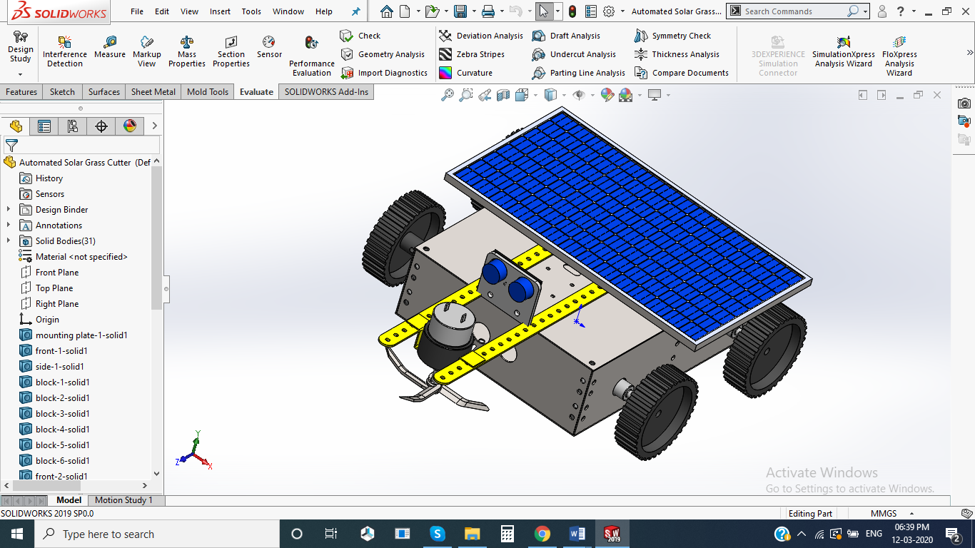

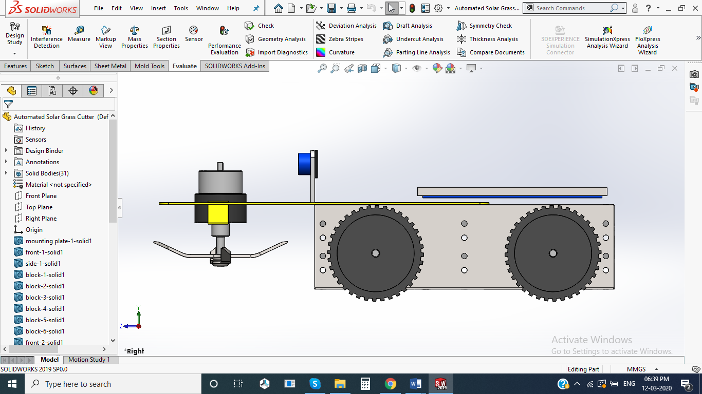

**Components:**

* 8051 Microcontroller
* Robotic Chassis
* Grass Cutting Blade
* Solar Panel
* Crystal Oscillator
* Resistors
* Capacitors
* Transistors
* Cables and Connectors
* Diodes
* PCB and Breadboards
* LED
* Transformer/Adapter
* Push Buttons
* Switch
* IC
* IC Sockets

**Fabrication Processes used**

**Laser Beam Machining (LBM)**

Lasers are used for many purposes. One way they are used is for cutting metal plates. On mild steel, stainless steel, and aluminum plate, the laser cutting process is highly accurate, yields excellent cut quality, has a very small kerf width and small heat affect zone, and makes it possible to cut very intricate shapes and small holes.

Most people already know that the word “LASER” is actually an acronym for Light Amplification by Stimulated Emission of Radiation.

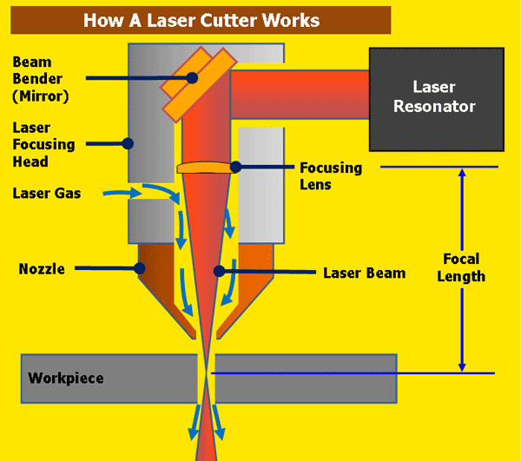

The laser beam is a column of very high intensity light, of a single wavelength, or color. In the case of a typical CO2 laser, that wavelength is in the Infra-Red part of the light spectrum, so it is invisible to the human eye. The beam is only about 3/4 of an inch in diameter as it travels from the laser resonator, which creates the beam, through the machine’s beam path. It may be bounced in different directions by a number of mirrors, or “beam benders”, before it is finally focused onto the plate. The focused laser beam goes through the bore of a nozzle right before it hits the plate. Also flowing through that nozzle bore is a compressed gas, such as Oxygen or Nitrogen.

Focusing the laser beam can be done by a special lens, or by a curved mirror, and this takes place in the laser cutting head. The beam has to be precisely focused so that the shape of the focus spot and the density of the energy in that spot are perfectly round and consistent, and centered in the nozzle. By focusing the large beam down to a single pinpoint, the heat density at that spot is extreme. Think about using a magnifying glass to focus the sun’s rays onto a leaf, and how that can start a fire. Now think about focusing 6 KWatts of energy into a single spot, and you can imagine how hot that spot will get.

The high power density results in rapid heating, melting and partial or complete vaporizing of the material. When cutting mild steel, the heat of the laser beam is enough to start a typical “oxy-fuel” burning process, and the laser cutting gas will be pure oxygen, just like an oxy-fuel torch. When cutting stainless steel or aluminum, the laser beam simply melts the material, and high pressure nitrogen is used to blow the molten metal out of the kerf.

On a CNC laser cutter, the laser cutting head is moved over the metal plate in the shape of the desired part, thus cutting the part out of the plate. A capacitive height control system maintains a very accurate distance between the end of the nozzle and the plate that is being cut. This distance is important, because it determines where the focal point is relative to the surface of the plate. Cut quality can be affected by raising or lowering the focal point from just above the surface of the plate, at the surface, or just below the surface.

There are many, many other parameters that affect cut quality as well, but when all are controlled properly, laser cutting is a stable, reliable, and very accurate cutting process.

**Advantages of LBM:**

* Tool wear and breakage are not encountered.
* Very small holes with large aspect ratio can be achieved.
* A wide variety of hard and difficult-to-machine materials can be tackled.
* Machining is extremely rapid and the setup times is economical.
* Holes can be located accurately by using an optical laser system for alignment.
* The operating cost is low.

**Lathe Machine Operations:**

**Facing**

Facing is the operation of machining the ends of a piece of work to produce flat surface square with the axis. The operation involves feeding the tool perpendicular to the axis of rotation of the work.

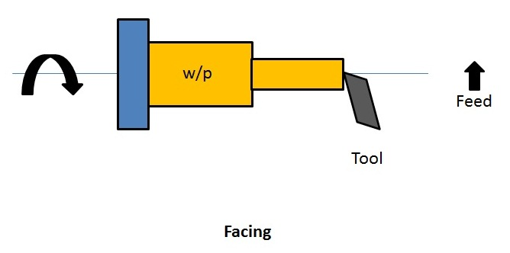

**Turning**

Turning in a lathe is to remove excess material from the workpiece to produce a cylindrical surface of required shape and size.

* **Straight turning:**The work is turned straight when it is made to rotate about the lathe axis and the tool is fed parallel to the lathe axis. The straight turning produces a cylindrical surface by removing excess metal from the workpieces.

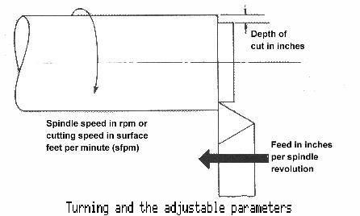

* **Step turning:** Step turning is the process of turning different surfaces having different diameters. The work is held between centres and the tool is moved parallel to the axis of the lathe. It is also called shoulder turning.

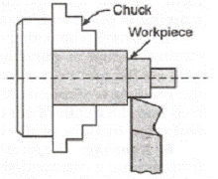

**Eccentric turning**

If a cylindrical workpiece has two separate axes of rotating, one being out of centre to the other, the workpiece is termed as eccentric and turning of different surfaces of the workpiece is known as eccentric turning. The distance between the axes is known as offset. Eccentric turning may also be done on some special machines. If the offset distance is more, the work is held by means of special centres. If the offset between the centres is small, two sets of centres are marked on the faces of the work. The work is held and rotated between each set of centres to machine the eccentric surfaces.

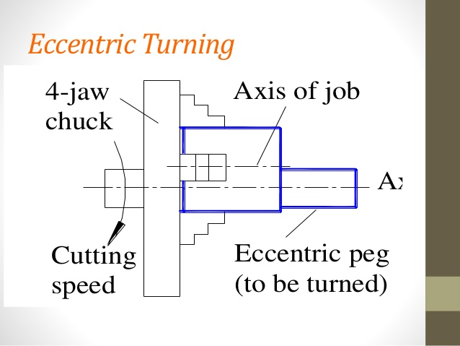

**Taper turning**

**Taper**

A taper may be defined as a uniform increase or decrease in diameter of a piece of work measured along its length.

Taper turning methods

1. Form tool method
2. Compound rest method
3. Tailstock set over method
4. Taper turning attachment method
5. Combined feed method
6. **Form tool method**

A broad nose tool is ground to the required length and angle. It is set on the work by providing feed to the cross-slide. When the tool is fed into the work at right angles to the lathe axis, a tapered surface is generated.

This method is limited to turn short lengths of taper only. The length of the taper is shorter than the length of the cutting edge. Less feed is given as the entire cutting edge will be in contact with the work.

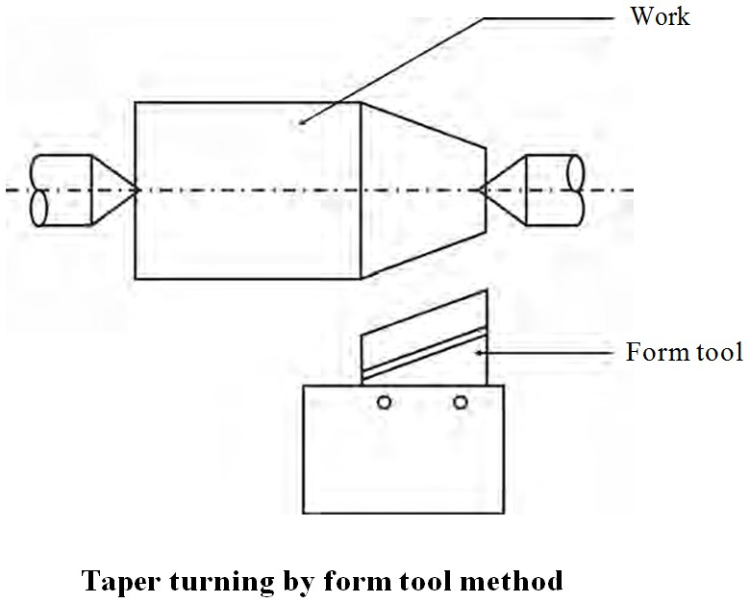

1. **Compound rest method**

The compound rest of the lathe is attached to a circular base graduated in degrees, which may be swiveled and clamped at any desired angle. The angle of taper is calculated using the formula

Where,

The compound rest is swiveled to the angle calculated as above and clamped. Feed is given to the compound slide to generate the required taper.

1. **Tailstock setover method**

Turning taper by the setover method is done by shifting the axis of rotation of the workpiece at an angle to the lathe axis and feeding the tool parallel to the lathe axis. The construction of tailstock is designed to have two parts namely the base and the body. The base is fitted on the bed guideways and the body having the dead centre can be moved at cross to shift the lathe axis.

The amount of setover – S, can be calculated as follows

The dead centre is suitably shifted from its original position to the calculated distance. The work is held between centres and longitudinal feed is given by the carriage to generate the taper.

The advantage of this method is that the taper can be turned to the entire length of the work. Taper threads can also be cut by this method.

The amount of setover being limited, this method is suitable for turning small tapers (approx. upto 8°). Internal tapers cannot be done by this method.

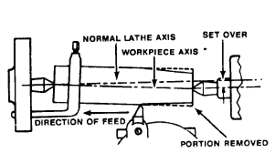

1. **Taper attachment method**

The taper attachment consists of a bracket which is attached to the rear end of the lathe bed. It supports a guide bar pivoted at the centre. The bar having graduation in degrees may be swiveled on either side of the zero graduation and set at the desired angle to the lathe axis. A guide block is mounted on the guide bar and slides on it. The cross slide is made free from its screw by removing the binder screw. The rear end of the cross slide is tightened with the guide block by means of a bolt. When the longitudinal feed is engaged, the tool mounted on the cross slide will follow the angular path as the guide block will slide on the guide bar set at an angle of the lathe axis. The depth of cut is provided by the compound slide which is set parallel to the cross-slide.

The advantage of this method is that long tapers can be machined. As power feed can be employed, the work is completed at a shorter time. The disadvantage of this method is that internal tapers cannot be machined.

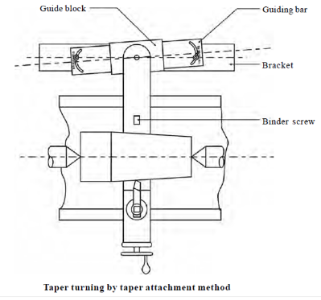

1. **Combined feed method**

Feed is given to the tool by the carriage and the cross-slide at the same time to move the tool at resultant direction to turn tapers.

**Drilling operation:**

It is the process of producing cylindrical hole in the workpiece. In this operation, Workpiece is held in a chuck or a suitable device and the drill is held in the tailstock. During operation, the drill is fed by rotating the handwheel of the tailstockin clockwise direction. First a shorter length is drilled by using a smaller and shorter drill, followed by producing the required diameter with the help of correct drill size.



**Reaming Operation**

It is a finishing operation because a very small amount of material is removed during the operation. For performing reaming a multi-teeth tool is used, which is called as reamer. During the operation, the workpiece is held in a chuck or face plate and the reamer shank is fitted in a sleeve or inserted in the tapered hole of the tailstock spindle.

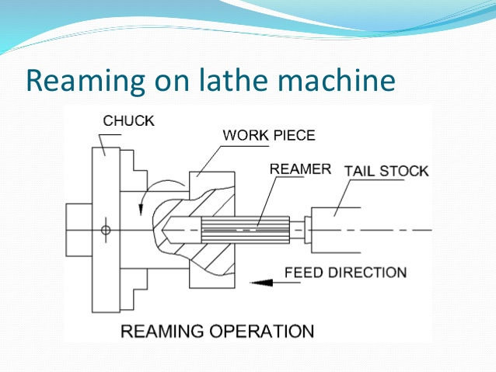

**Boring Operation:**

It is an operation which is employed for machining internal surfaces, hence also called as internal turning. Boring is done to enlarge the already drilled hole and bring them to the exact required size. Generally, a single point cutting tool is used for this purpose.

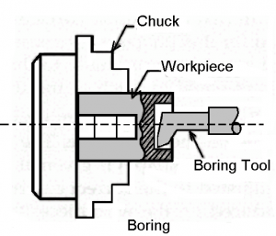

**Knurling**

Knurling is the process of embossing a diamond shaped pattern on the surface of the workpiece. The knurling tool holder has one or two hardened steel rollers with edges of required pattern. The tool holder is pressed against the rotating work. The rollers emboss the required pattern. The tool holder is fed automatically to the required length. Knurls are available in coarse, medium and fine pitches. The patterns may be straight, inclined or diamond shaped.

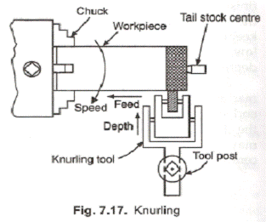

**Thread cutting**

Thread cutting is one of the most important operations performed in a lathe. The process of thread cutting is to produce a helical groove on a cylindrical surface by feeding the tool longitudinally.

1. The job is revolved between centres or by a The longitudinal feed should be equal to the pitch of the thread to be cut per revolution of the work piece.
2. The carriage should be moved longitudinally obtaining feed through the leadscrew of the
3. A definite ratio between the longitudinal feed and rotation of the headstock spindle should be found Suitable gears with required number of teeth should be mounted on the spindle and the leadscrew.
4. A proper thread cutting tool is selected according to the shape of the It is mounted on the toolpost with its cutting edge at the lathe axis and perpendicular to the axis of the work.
5. The position of the tumbler gears are adjusted according to the type of the thread (right hand or left hand).
6. Suitable spindle speed is selected and it is obtained through back
7. Half nut lever is engaged at the right point as indicated by the thread chasing
8. Depth of cut is set suitably to allow the tool to make a light cut on the
9. When the cut is made for the required length, the half nut lever is The carriage is brought back to its original position and the above procedure is repeated until the required depth of the thread is achieved.
10. After the process of thread cutting is over, the thread is checked by suitable gauges.

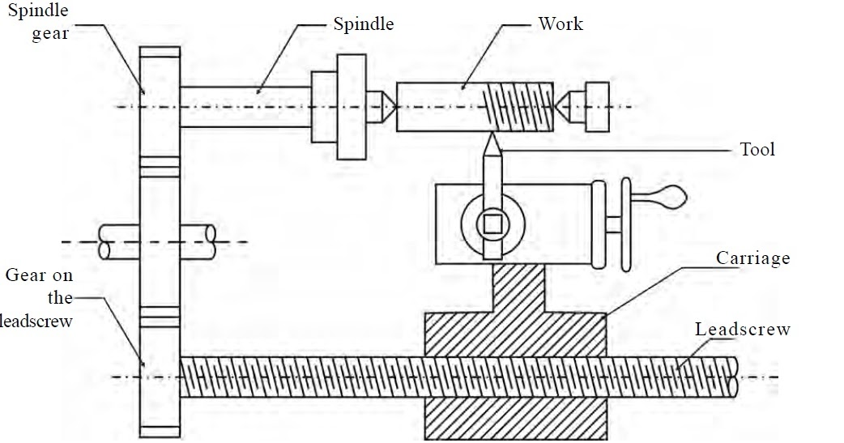

**Chamfering**

Chamfering is the operation of bevelling the extreme end of the workpiece. The form tool used for taper turning may be used for this purpose. Chamfering is an essential operation after thread cutting so that the nut may pass freely on the threaded workpiece.

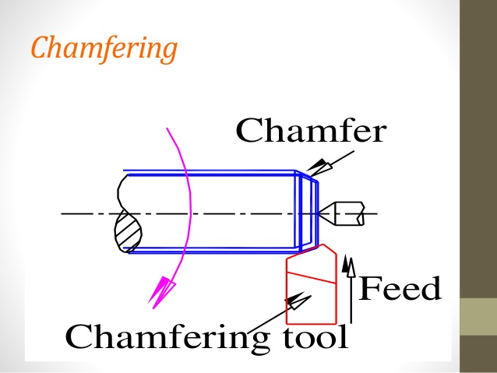

**Grooving**

Grooving is the process of cutting a narrow goove on the cylindrical surface of the workpiece. It is often done at end of a thread or adjacent to a shoulder to leave a small margin. The groove may be square, radial or bevelled in shape.

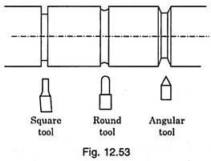

**Forming**

Forming is a process of turning a convex, concave or any irregular shape. For turning a small length formed surface, a forming tool having cutting edges conforming to the shape required is fed straight into the work.

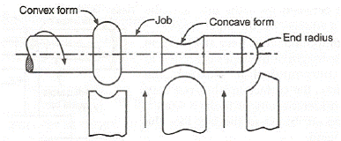

**Conclusion**

Our project entitled Manufacturing of solar powered grass cutter is successfully completed and the results obtained are satisfactory. It will be easier for the people who are going to take the project for the further modifications. This project is more suitable for a common man as it is having much more advantages i.e, no fuel cost, no pollution and no fuel residue, less wear and tear because of less number of moving components and this can be operated by using solar energy. This will give much more physical exercise to the people and can be easily handled. This system is having facility of charging the batteries while the solar powered grass cutter is in motion. So it is much more suitable for grass cutting also. The same thing can be operated in night time also, as there is a facility to charge these batteries in day light.

**Future Scope**

We completed our project successfully with the available sources. But the results and modifications are not up to the expectations. This can be further improved by incorporating the following modifications to obtain better results.

Design of blades should be done based on types of grass is used to cut. The project which we have done surly reaches the average families because the grass can be trimmed with minimum cost and with minimum time. Finally this project may give an inspiration to the people who can modify and can obtain better results.